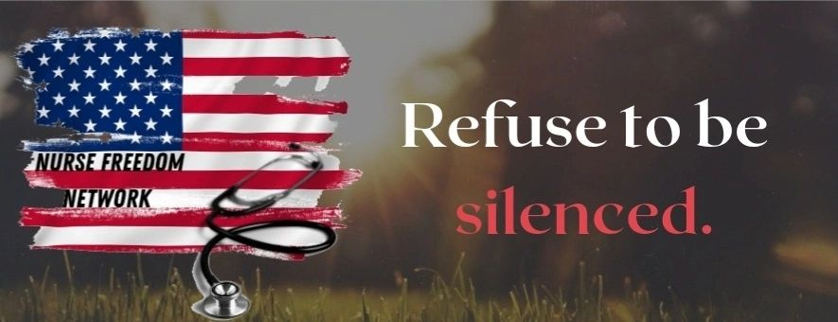

Dear ______________,
My name is Kimberly Overton. I'm a registered nurse with a background in critical care and telehealth nursing. I am also the founder & CEO of a newly formed non-profit organization called Nurse Freedom Network.
Our mission is advocating for medical freedom and informed consent for healthcare workers and all Tennesseans. We are also strong advocates for early treatment in the fight against Covid-19.
Over the past two years, I have witnessed unethical and profit-driven policies that have harmed and even taken the lives of Tennesseans. To stop the harm now and in the future, I am writing today to voice my support for the following bills that will be coming before you for consideration.
- Patient's Bill of Rights
HB2486 & SB2276
- Let Doctors Be Doctors (prohibits licensing boards from threatening doctors and pharmacists for prescribing certain protocols)
HB1870 & SB1880
- Natural Immunity
HB1871 & SB1982
- Ivermectin as Standing Order
HB2506 & SB2621
- Ivermectin Over the Counter
HB2746 & SB2188

HB2486/SB 2276 Patient’s Bill of Rights. This bill addresses many specific issues that have been disregarded for far too long, specifically, Section 68-11-2204 – Right to alternative treatment, Section 68-11-2205 – Right to transfer from care, Section 68-11-2206, Right to access an advocate, Section 68-11-2209, Right to a transplant, and Section 68-11-2210, Right to avoid discrimination in admission or treatment. I suggest adding “vaccination status” to this list as I have received an alarming number of reports from multiple patients of despicable treatment and discrimination based upon their decision not to receive the Covid vaccine. As a critical care nurse, particularly during this pandemic, I saw first-hand, the dire need in which all of these areas needed to be addressed. I have been a strong advocate for patient’s rights throughout my career, with autonomy and informed consent being at the forefront. This bill would guarantee appropriate care and treatment of individuals, and I am in strong support of it.

HB1870/SB1880 Let Doctors Be Doctors. The practice of prescribing medication for “off label” or “repurposed” use is one that has been employed by healthcare practitioners for several decades. It is a practice that is legal, and after nearly thirty years working in the healthcare industry, I can attest to the fact that this practice is an exceedingly common one. Off-label use simply means that a prescribing practitioner is writing a prescription for an FDA-approved medication to treat a disease or condition other than for its original licensed use. Here are just a couple of examples: The drug Metformin, approved in the treatment of Type II Diabetes Mellitus is often prescribed for weight loss, an off-label use; the drug Neurontin, originally developed and approved for use in the treatment of seizures, has a long list of off-label uses that doctors frequently prescribe for, including nerve pain, restless leg syndrome (RLS), Attention-Deficit Hyperactivity Disorder (ADHD), migraine headaches, drug and alcohol withdrawals, and trigeminal neuralgia, just to name a few. It is important to note that the FDA regulates the approval of medications, NOT the practice of medicine. Physicians need to be allowed to rely upon their clinical judgement, based upon their knowledge and personal experience in treating patients. Healthcare is not one size fits all. Please support this bill and allow doctors to be doctors without threat of disciplinary action when acting in the best interests of their patients.
HB1871 & SB1982 Natural Immunity. Multiple studies have proven what we have long known to be true – that natural immunity is durable, complete, and robust, and is far superior to any immunity derived by artificial means. When we are talking about following actual science, the science of natural immunity cannot be ignored. (Source: https://brownstone.org/articles/natural-immunity-and-covid-19-twenty-nine-scientific-studies-to-share-with-employers-health-officials-and-politicians/)

HB2506 & SB262 Ivermectin as a standing order. I strongly support this bill that would allow a pharmacist to dispense the Nobel Prize winning Ivermectin in accordance with a prescribed protocol for a designated health condition, i.e., Covid-19.
HB2746 & SB2188 Ivermectin OTC. As a critical care nurse who worked throughout this pandemic, I have seen firsthand how devastating the effects of this virus can be; but I have also seen firsthand the incredible results derived from EARLY intervention with safe, effective, re-purposed therapeutics. Since the Covid vaccines do not prevent transmission of SARS-CoV-2 (the virus) but may only prevent or reduce complications of Covid-19 (the manifestation of symptoms) for a limited time, even the vaccinated need access to early treatment protocols. It is prudent to use every tool in our toolbox to combat this virus, including the use of safe, effective, re-purposed, FDA-approved drugs. Despite what the mainstream media will tell you, Ivermectin has been safely used, in humans, for over three decades, and has a higher safety profile than that of an aspirin, and far safer than Tylenol (a brand name of acetaminophen.) Currently, acetaminophen is the major cause of acute liver failure in the United States, Europe and Australia. (https://www.ncbi.nlm.nih.gov/books/NBK548162/). In comparison, it’s nearly impossible to find any deaths associated with ivermectin anywhere in the world. So why are doctors, nurses, and medical systems so carelessly suggesting to Covid patients that they take acetaminophen, giving Tylenol to hospital patients, but access to Ivermectin is being restricted?
Ivermectin is safe, effective, affordable, and up until just recently, widely available. As a nurse, I have stood at the bedside of my patients as they took their last breath following a long and arduous battle against Covid-19, and the most difficult part of that was knowing that it didn’t have to be this way. I would implore you to vote yes and to make this life-saving medication easily accessible to all Tennesseans. I strongly encourage everyone to keep this medication on-hand in the event that it becomes needed so that treatment can begin upon first symptom, as recommended by the front line doctors. It could quite literally mean the difference between life and death.

Thank you for your time and careful consideration on these important issues. It is my sincere hope that you will be a champion for medical freedom and a strong voice for all Tennesseans when you vote in support of the above bills.

Respectfully,

Kimberly Overton, BSN, RN
Founder/CEO
Nurse Freedom Network
615-495-0707
kimberly@nursefreedomnetwork.org

